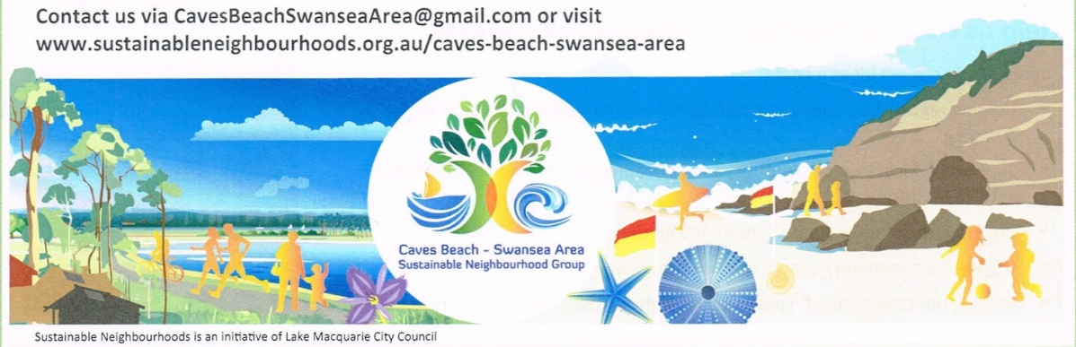

**CALM’D - SCHOOL ART COMPETITION- 2017**

**(Coast And Lake Marine Debris - School Art Competition)**

**About Competition and Exhibition.** This competition is open to local Primary and High Schools in the Swansea/ Caves Beach area. It is intended to Educate, to Challenge and to Stimulate the imagination of our local school communities to create art works made from Marine Debris items which are found around the parks and foreshores of our local water ways, including the Channel, the beaches, the bays and the Lake. At the same time, create an awareness of the effects this debris can have on our Marine Environment.

**The Exhibition** will be held in Swansea Community Centre from the evening of Friday 20th October 2017 till Sunday 22nd October 2017 in conjunction with The Swansea Centre Art Show.

Winning and Highly commended works will be exhibited in the Finite Art Gallery, Caves Beach for 1 week commencing 23rd October 2017. Other selected works to be exhibited in Swansea Library for 1 week from 23rd October 2017.

**Entries will be Judged on**

* The Demonstrated use of Marine Debris (at least 40%)
* Creativity and skill
* **A story to accompany artwork**, from 100 to 200 words, detailing the experience and knowledge gained from learning about Marine Debris and the effects on our Waterways and Oceans.

**Prizes will be awarded**

**Certificates of Participation will be given to all Entries.**

**Terms and Conditions**

* Entry is free
* Primary schools will enter as a class. High Schools will enter as Individual
* Artworks must contain **at least 40% Marine Debris** and can be either
* a collage suitable to hang and no larger than 1m x 1m and no heavier than 10kg
* a sculpture no larger than 1 m cubed and be no heavier than 20kg
* Deliver Artworks to Swansea Community Centre by Thursday 19th October.
* Marine Debris items that are used must be clean and Artworks must not contain dangerous items that could cause injury.
* Caves beach Swansea Area Sustainable Neighbourhood Group accepts no responsibility for artworks that may be damaged during viewing or for any loss or damage that occurs.

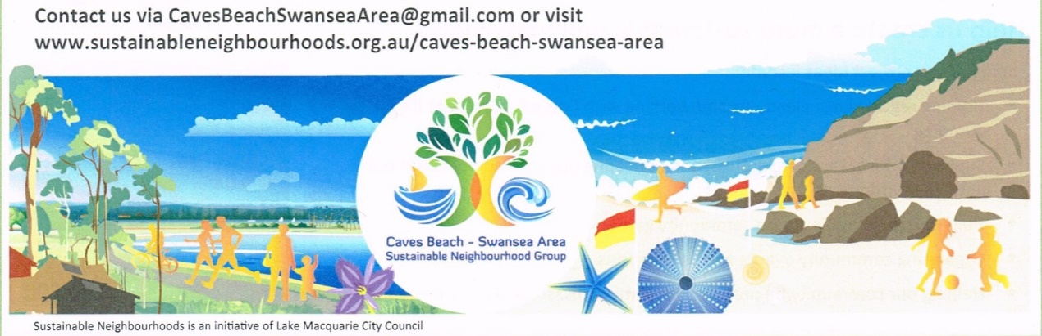

**CALM’D - SCHOOL ART COMPETITION- 2017**

**(Coast And Lake Marine Debris - School Art Competition)**

**(Caves Beach Primary, Swansea Primary, St. Patrick’s Primary and Swansea High School)**

**\*Registration of Entries Opens - Friday 8th September 2017**

**\*Registration of Entries Closes - Thursday 12th October2017**

**\* All Entries must be received in the downstairs front hallway at Swansea Community Centre by Thursday 19th October 2017 between 12 and 5pm.**

**Exhibition and judging will be held at Swansea Community Centre from Friday 20th October until Sunday 22nd October 2017. Selected works will then be exhibited for one week at both Caves Beach Finite Art Gallery and Swansea Library.**

**REGISTRATION FORM. REGISTRATION NUMBER: ________ (office use only)**

**Category of Entry:**

* **Primary School Name _______________________________________________________**

**Primary -- Year/ Class ______________________________________________________**

* **High Sch. Student Name ______________________________________________Year_____**

**Age________ Guardian Consent (if under 18yrs) ___________________________________**

**ALL ENTRANTS**

**Contact Email: _________________________________ Ph. Number: _____________________**

**I wish to register an entry for the CALM’D – SCHOOL ART COMPETITION.I agree to abide by the terms and conditions of entry. I declare that the entry is an original work and contains no dangerous components. I give permission for photos of artworks to be used for promotional purposes.**

**Signed: (Teacher or High School Student)____________________________________________**

**Name: ________________________________________________________________________**

**Please email this form to CavesBeachSwanseaArea@gmail.com**

**Or post to # C. Douglass / The School Art Competition – CBSASNG**

**9 Silver Birch Close, Caves Beach: NSW. 2281**